AMBSC

CODE PART 4

DUPLEX STEEL BOILERS

Printed 1st. August 2009
Contents
Page
PREFACE ……………………………………………………………………………. 1

SECTION 1 GENERAL REQUIREMENTS
1.1 Scope …………………………………………………………………… 2
1.2 Purpose …………………………………………………………………. 2
1.3 Definitions ………………………………………………………………. 3

SECTION 2 MATERIAL
  - Duplex Steel S31803…………………………………………………… 4
  - Welding materials………………………………………………………. 4
  - Welding procedure……………………………………………………… 5

SECTION 3 DESIGN
  - Compliance……………………………………………………………… 7
  - Design Approval………………………………………………………… 7
  - Barrels, Shells and Plates……………………………………………… 8
  - Tubes and Flues………………………………………………………… 8
  - Firebox Water Spaces………………………………………………….. 8
  - Tubeplates………………………………………………………………. 8
  - Stays and Stayed Surfaces……………………………………………. 9
  - Bushes, Mountings and Domes……………………………………….. 10
  - Superheaters……………………………………………………………. 12

SECTION 4 CONSTRUCTION
  - General…………………………………………………………………... 13
4.1.1a Example of Duplex Steel Boiler assembly………...………………… 14
4.1.2a Typical Firebox Stays………………………………………………….. 15
4.2 Joint Design……………………………………………………………... 16
4.3 GTA Welding and Weld Preparation...……………………………….. 16

SECTION 5 FITTINGS
  - Safety Valves……………………………………………………………. 18
  - Pressure Gauges……………………………………………………….. 20
  - Water Gauges………………………………………………………....... 20
  - Feedwater Systems…………………………………………………….. 21
  - Blowdown Valves……………………………………………………….. 21
  - Washout Plugs………………………………………………………….. 21
  - Fusible Plugs……………………………………………………………. 21
  - Valves……………………………………………………………………. 22

SECTION 6 SUPPORT
6.1 Boiler Support Description and Drawings……………………………. 22, 23 & 24

Contents
Page
SECTION 7 INSPECTION AND TESTING
  - Inspection………………………………………………………………... 25
  - Testing…………………………………………………………………… 26
  - Retesting………………………………………………………………… 27
  - Rejection…………………………………………………………………. 27

SECTION 8 IMPORTED BOILERS
- Imported Boilers………………………………………………………… 28

SECTION 9 OPERATION
  - Water Quality……………………………………………………………. 28
  - Water Level……………………………………………………………… 28
  - Raising Steam…………………………………………………………... 28
  - Loss of Water or other Incidents………………………………………. 29
  - Shutting Down…………………………………………………………... 29

SECTION 10 ADMINISTRATION
  - Registration of New Clubs or Societies………………………………. 30
  - Winding Up………………………………………………………………. 30
  - Change of Ownership or Disposal of Boiler or Air Receiver……….. 30

APPENDIX 1
AMBSC Boiler Inspector Qualifications………………………………. 31

APPENDIX 2
Examples of AMBSC Forms ………………………………………….. 32

APPENDIX 3
AMBSC Registered Societies ………………………………..……….. 35

APPENDIX 4
Typical Design Submission Requirements for
Regulatory Design Registration ………………………………………. 39

APPENDIX 5
Commercial Supply…………………………………………………….. 40

APPENDIX 6
Suggested Welding Sequence for Duplex Steel
Miniature Locomotive Boiler (for copying)…………………………... 41

APPENDIX 7
Welding Procedure (for copying)…………………………………….. 42

APPENDIX 8
Typical GTA Welded Joints (for copying)…………………………….. 44

PREFACE
————————————————————————————————————
This code has been compiled by the sub-committee appointed at the 2008 Annual General Meeting of the Australian Miniature Boiler Safety Committee.

The Committee consisted of:
Chairman: Les Irwin
Hon. Secretary Frank Tynan
Drawings by Martin Greaves and Peter Manning

AALS Technical Contribution
Central Coast Lyndsay Brack...Pressure Welding Instructor
Roseworthy Andrew Mathews
Penwood Peter Glover...Engineering Company Director
Castledare Dr. Richard Stuart...Oil and Gas Pipeline Engineer

External Technical Consultation
Metallurgists: Dr Ian Ward………..... Sandvik
Robert Brunton………BSC University of NSW

Welding Engineer Kurt Staub……………Sandvik

1. GENERAL REQUIREMENTS

1.1 SCOPE

1.1.1 This code applies to the design, construction and testing of miniature Duplex Steel fire tube boilers in which steam is generated and miniature air receivers in which compressed air is stored for use in the operation of miniature locomotives, traction engines, and other live steam models.

For Copper boilers, refer to AMBSC Codes Part 1 and Part 3.

For steel boilers refer to AMBSC Code Part 2, Steel Boilers, latest issue.

    - Boilers and air receivers that are inspected and certified by AMBSC registered boiler inspectors shall not exceed the following limits:

- The working pressure shall not exceed 700 kPa (100 psi).
- The maximum outside diameter of parallel barrels or shells and the mean outside diameter of tapered barrels shall not exceed 325mm

- The gross water capacity shall not exceed 50 litres for fire tube boilers and 25 litres for air receivers.

    - Boilers and air receivers of larger capacity and/or working pressures and/or larger dimensions than allowed in clause 1.1.2 shall be submitted to a regulatory authority for design registration/notification according to the relevant Australian Design Standard.

1.2 PURPOSE

    - The purpose of this code is to ensure that miniature Duplex steel boilers and air receivers are designed and constructed to a high standard of safety.

This code also provides a common basis for AALS subscribing clubs, AMBSC boiler inspectors and regulatory authorities.

1.2.2. This Code is not intended to restrict experimentation and development. Any type of boiler or air receiver may be built to this code, provided that all material, strength and safety aspects meet the requirements of this Code.

1.2.3 In reading this code, designers, builders and boiler inspectors should recognise that the requirements represent only a minimum standard of safety. Thicker materials may be used if desired.

1.2.4 A current valid boiler certificate issued under this Code by any of the clubs or societies listed in APPENDIX 3 shall be acceptable to all other clubs listed.

1.2.5 A current Design Acceptance Certificate issued by the State Regulator in the state of operation, or by a Regulator acceptable to that State Regulator, shall be recognised by all Clubs and Societies registered with the AMBSC.
1.2.6 Inspection and certification of boilers under this code shall be carried out by boiler inspectors appointed by clubs registered with the AMBSC. Boilers owned by non-members may be inspected at the discretion of the club management, taking into account any effect on the club’s insurance policies.

If acceptable, the certificate is to be endorsed “NON MEMBER”. This certificate shall take the form of the normal certificate and may be accepted by a club at the discretion of its boiler inspector.

1.3 DEFINITIONS

1.3.1 Miniature Duplex steel boilers and miniature air receivers are those vessels which:

a) Are for use under working conditions on miniature railways, traction engines, ships, stationary engines and similar applications and,

b) Consist of closed vessels in which steam is generated (boilers) or compressed air is stored (air receivers) to a maximum working pressure of 700 kPa (100 psi) see clause 1.1.2 and,

c) Are constructed of those grades of Duplex steel and welded in accordance with section 2 of this code.

1.3.2. “SHALL” is to be understood as being mandatory. “SHOULD” is advisory.

    - “FITTINGS” are those appurtenances attached to the vessel to allow safe operation.

    - “MOUNTINGS” or “BUSHES” are places where provision is made for attaching those fittings described in 1.3.3. Mountings are also used to locally strengthen the shell of a vessel for the attachment of brackets, bearers, etc., for fixing of the vessel to a frame, or for attaching traction engine cylinders (Refer Section 6).

    - “DESIGN PRESSURE” is the maximum allowable pressure at which the vessel is to operate, including accumulation.

    - “WORKING PRESSSURE” is the pressure to which the vessel is certified by the AMBSC boiler inspector (not including accumulation). The working pressure shall not exceed the design pressure.

Note: All pressures quoted in this Code are gauge pressures.

1.3.7 “GROSS WATER CAPACITY”, for the purpose of calculation for acceptance, is the volume of the outer shell or barrel, outer firebox and dome(s) MINUS the volume of the inner firebox and tubes. The gross water capacity of a boiler or air receiver is the total volume of water when hydrostatically full.

1.3.8 “AMBSC boiler Inspector” is a person appointed by a registered club or society to carry out design approval, inspections and tests in accordance with AMBSC Codes parts 1, 2, 3 & 4 for members of that club or society. Qualifications necessary for appointment as AMBSC boiler are detailed in APPENDIX 1.

2. MATERIAL

  - SHALL BE DUPLEX STEEL FERRITIC AUSTENITIC TYPE UNS S31803 SANDVIK SAF2205

ASTM A 240 (PLATE SHEET AND STRIP)

ASTM A 276 (BARS AND SHAPES)

ASTM A 789 (SEAMLESS AND WELDED TUBE)

ASTM A 790 (SEAMLESS PIPE)

UNS S31803 (ANNEALED)

- Tensile strength 620 MPa (90,000 PSI)
- Yield strength 450 MPa (65,000 PSI)
- Elongation 25%
- Reduction of area 45%

2.2 WELDING MATERIALS

    - GAS TUNGSTEN ARC WELDING (GTAW) CONSUMABLES SANDVIK 22.8.3.L WELDING WIRE OR SIMILAR.

Suitable for welding:
- Duplex Steel to Duplex Steel
- Duplex Steel to 300 Series Stainless Steel
- Duplex Steel to Carbon Steel

Note: To be inspected and approved by the boiler inspector and then handed to the welder (with instructions that no other filler rod of any description be used) together with a copy of the welding procedure.

2.2.2 Silver or bronze brazing filler metals shall not be used on any part of the Duplex steel boiler or pressure vessel.
2.3 Welding Procedure

2.3.1 A copy to be given to welder before commencement of welding.
(Refer Appendices 6, 7 & 8)

2.3.2 Welding shall only be gas tungsten arc welding (GTAW) commonly known as TIG welding, to AS1167.2

    - All welding shall be performed by persons certified in accordance with AS1796 for pressure vessel welding, or by persons under direct supervision of a welding supervisor certified in accordance with AS1796.

2.3.4 Welding quality Argon shall be used for all GTAW weldmets per AS3992, clause 2.2 “pre-qualified gases”.

2.3.5 Suggested Argon flow rate of 8-9 litres/min.

2.3.6 Welding polarity DC negative to torch.

2.3.7 Thoriated Tungsten electrode diameter 2.5mm.

2.3.8 Welding consumables shall be 2.5mm diameter Sandvik type 22.8.3.L or equivalent.

Note: No other consumables to be substituted under any circumstance. The welding consumables are to be verified by boiler inspector and then supplied to the welder by the owner; reinforcing the requirement that no substitution of consumables is allowed.

2.3.9 Work area to be clean and free of contaminants.

2.3.10 Degrease boiler components in detergent, rinse with clean water and allow to dry.

2.3.11 New, clean, stainless steel grinding wheels only to be used for any grinding, to avoid contamination of duplex steel or weldmet.

2.3.12 Tack weld approximately 100mm apart or as required.

2.3.13 All tack welds to be ground out before welding over tack area.

2.3.14 Ensure a tight fit-up with a minimum of 2mm lap for welding of joints 85-90A and 125-130A (Figure 4.2.1a). This allows a weldmet without the need of backing strips or purging gas. This tight fit-up is important as this method prevents the loss of nitrogen from the back of the weld.

2.3.15 Full penetration is to be avoided on all lap joints. The currents suggested with each type of weld should achieve approximately 1mm penetration.

2.3.16 If full penetration occurs, the back of the weld shall be ground out and a capping run over the ground area. Strongly suggest fabricating test pieces from scrap and proving penetration depth prior to welding of pressure vessel.

2.3.17 Longitudinal and circumferential butt welds, 85-90A shall be close fit up and welded along prepared joint; followed by a capping run to rear of the weld to provide a full penetration weldmet.

Alternatively, to achieve a full penetration weld from one side:

- Provide Argon purging gas to rear of weld
- Provide 1mm root gap
- Weld full-penetration root run (key hole method)
- Weld capping run

2.3.18. Flue tubes to protrude 1mm though tube plate. Start weld with the addition of filler rod then complete weld by melting the tube end over into the tube plate. Use step-weld sequence and alternate between front and rear tube plates to reduce sheet distortion.

    - Stay ends to protrude 1mm past sheet surface. Start weld with the addition of filler rod then complete weld by melting end of stay over into the sheet. This is sometimes known as a “rosette” weld.

2.3.20. It is mandatory that all welds are finally pickled and scrubbed with a clean stainless steel wire brush followed by thorough rinsing.

2.3.21 It is important to follow the manufacturers’ instructions and safety guidelines together with correct procedures in disposal of these chemicals.

3. DESIGN

3.1 COMPLIANCE

The boiler or air receiver shall comply with one or more of the following:

3.1.1 AMBSC Code Part 4 Duplex Steel Boilers.

3.1.2 AS 1210 – 1997 – Pressure Vessels, published by Standards Australia for air receivers and AS 1228 – 2007 – Boilers, published by Standards Australia for boilers.

Note: Only designs complying with AMBSC Codes parts 1, 2, 3 and 4 may be approved by an AMBSC registered boiler inspector.

3.2 DESIGN APPROVAL

3.2.1 Persons who design a miniature boiler or air receiver to be used within the scope of this Code shall submit the design for approval to either of the following, who shall be independent of the designer.

a) An inspector approved by the AMBSC for this purpose.
(See definitions, Clause 1.3.8) or,

b) A person who can verify designs of plant items as defined by OH&S in NSW, and equivalent organisations in other States.

3.2.2. Constructors shall submit two copies of the finally approved drawings; one to be returned to the owner/builder endorsed “Approved for Construction”, signed and dated by the boiler inspector. The owner shall retain the returned drawing for transfer in the event of a change of ownership. The other copy should be retained by the boiler inspector as a record of the verified design.

It is most important that amateur constructors, particularly for “first attempts”, thoroughly discuss their project with an AMBSC boiler inspector prior to commencing, and during construction. This may prevent disappointment, or rejection of the work.

3.2.3 The design of a miniature boiler must comply fully with the requirements in this Code. If a designer wishes to depart from the requirements in this Code, then the proposed boiler must be designed in accordance with the applicable Australian Standard specified in the applicable State’s Regulation and obtain a design registration/notification number from the State Regulator (Refer APPENDIX 4).

3.3 BARRELS, SHELLS AND PLATES

3.3.1 Barrels and shells may be made from schedule 10 pipe complying with Section 2.1, or from flat plates complying with Section 2.1, formed to shape and joined using full penetration GTAW.

3.3.2 Minimum thickness for barrels, shells and plates in boilers or air receivers shall be 4mm or schedule10 pipe.

3.3.3 Longitudinal and circumferential seams in cylindrical shells should be located so as to be clear of openings for mountings, bushes or domes by at least 10mm where possible.

    - Holes in cylindrical shells shall be machine cut and reinforced by bushes or mounting rings GTA welded in position.

3.3.5 Forming, bending or rolling Duplex steel shall be carried out cold without heating or heat treatment. Minimum radius shall not be less than 20 mm.

3.4 TUBES AND FLUES

3.4.1 Fire tubes and flues shall be Duplex Steel UNS S31803 Schedule 10 pipe ASTM A790 or ASTM A789 tube for heat exchangers.

  - FIREBOX WATER SPACES

    - Water spaces around fireboxes shall have minimum widths in accordance with table 3.5.1a.

BOILER BARREL | MINIMUM FIREBOX WATER SPACE
Up to 200mm | 12mm
Over 200mm up to 320mm | 16mm

Table 3.5.1a FIREBOX WATER SPACES

3.6 TUBEPLATES

3.6.1 Tubeplates shall be made from Duplex Steel UNS S31803 complying with Section 2.1.

3.6.2 Tubeplates in fire-tube boilers shall have a minimum design ligament between tube holes of D/4, where D is the outside diameter of the tube, and shall not be less than 6mm. A manufacturing tolerance of minus 0.5mm is permitted on the ligaments.

3.6.3 Tubeplates forming the sides of cylindrical shells of water-tube boilers shall have a minimum design ligament between tube holes of D/4, where D is the outside diameter of the tube, and shall not be less than 6mm. A manufacturing tolerance of 0.5mm is permitted on the ligaments.

3.6.4 Tubeplates and backheads up to 150mm Ø shall have a minimum thickness of 6mm.

Tubeplates and backheads up to 250mm Ø shall have a minimum thickness of 8mm.

Tubeplates and backheads up to 320mm Ø shall have a minimum thickness of 10mm.

Firebox tube plates shall have a minimum thickness of 4mm.

Note: These thicknesses negate the requirement for longitudinal stays.
  - STAYS AND STAYED SURFACES

    - Stays for flat surfaces shall be made from Duplex Steel UNS S31803 complying with Section 2.1

    - Maximum square stay pitches of 75mm and a minimum stay diameter of 10mm for 4mm plate thickness represents the maximum stay pitch that may be used.

    - Stays may be placed in square, rectangular or irregular patterns.

Where stays are placed in square patterns, the pitch shall be a maximum of 75mm spacing.

Where stays are placed in rectangular patterns, the vertical pitch (A) and the horizontal pitch (B) shall be related to the square pitch (C) in such a way that A² + B² = 2C².

    - Where two plates of two different thicknesses are stayed together, the staying shall be as required for the thinner plate.

    - Type of rod stay that may be used is shown in Figure 3.7.5a below.

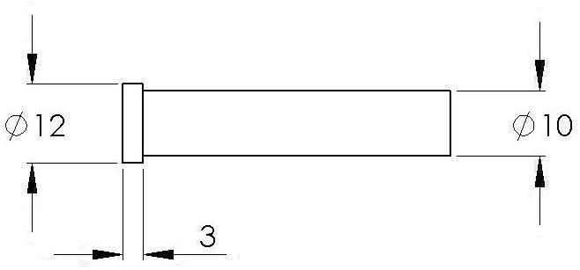

Figure 3.7.5a

3.8 BUSHES, MOUNTINGS and DOMES

3.8.1 Steam, water or other fittings shall be screwed to mountings or bushes GTA welded to the plates of the boiler or air receiver. Fittings shall not be screwed directly into plates.

    - Mountings, bushes and thickening pads shall be made of Duplex Steel UNS S31803 complying with Section 2.1 and GTA welded into place.

3.8.3 Silver or bronze brazing filler metals shall not be used on any part of the Duplex steel boiler or pressure vessel.

3.8.4 Suggested Threaded Bushes

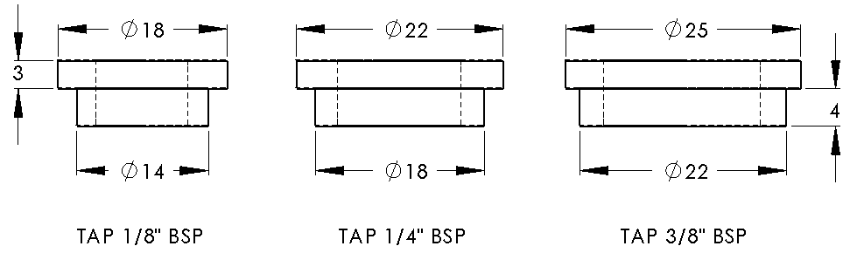

3.8.5 Recommended Proportions for Threaded Mounting and Domes.

Stud PCD mm | 25 | 32 | 38 | 45 | 50 | 65 | 75 | 85 | 100 | 125 | 150
Number of Studs/Bolts | 6 | 8 | 8 | 8 | 8 | 12 | 12 | 12 | 8 | 8 | 12
Stud / Bolt Size | M3 | M3 | M3 | M4 | M5 | M5 | M5 | M6 | M8 | M8 | M8

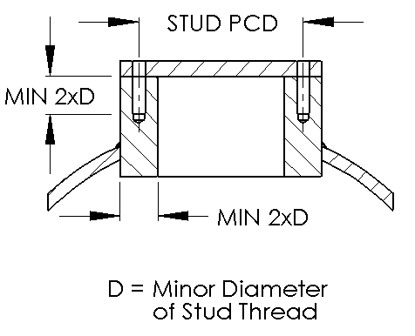

    - Typical Domes

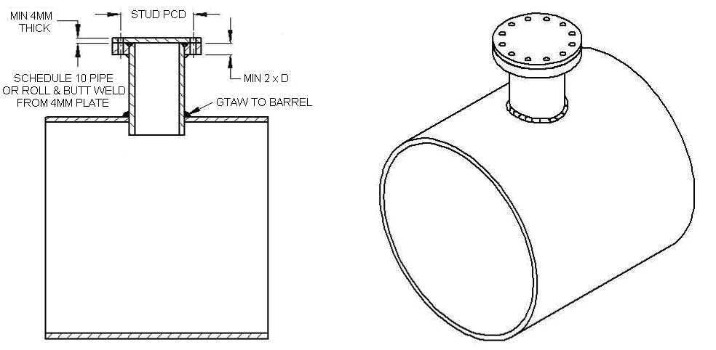

Figure 3.8.6a – Flange Dome and Cover

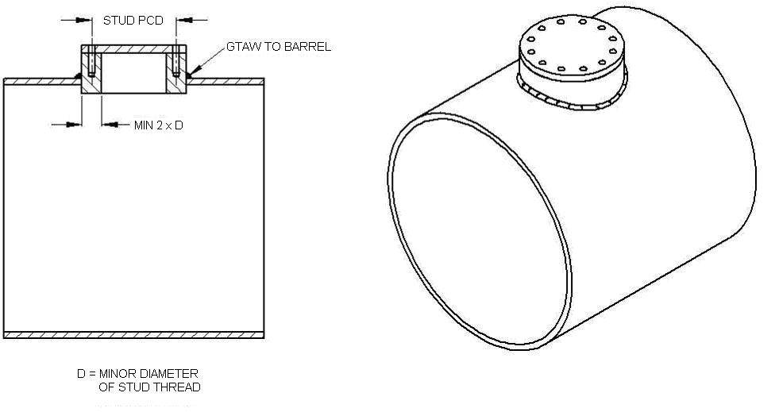Figure 3.8.6b – Threaded Dome and Cover
3.9 SUPERHEATERS

3.9.1 Suggested superheater designs are shown in Figure 3.9.4a. These designs are not exclusive; other types which comply with this Code may be used.

    - Superheater tubes of copper at the firebox end shall be bronze brazed. Joints at the smokebox end may be silver brazed.

    - Radiant superheaters shall be of Duplex Steel UNS S31803 complying with Section 2.1 and using GTA welded fabrication.

    - In boilers where the stop valve or regulator is at the superheater outlet, the superheater shall be tested by the AMBSC boiler inspector as a part of the boiler. Other superheaters should be tested by the builder as a check on construction.
COPPER SUPERHEATER TUBES
COPPER SPEAR POINT
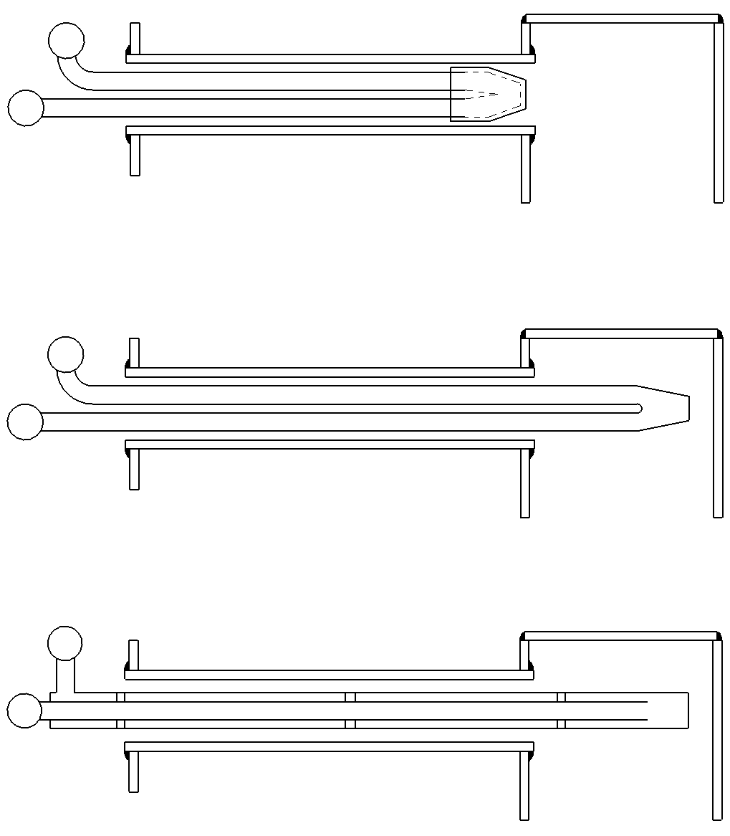
BRONZE BRAZE
FIREBOX
FIREBOX
FIREBOX
Type 1 STANDARD FLUE TUBE
Type 2 RADIANT STANDARD TUBE
Type 3 CONCENTRIC RADIANT TUBE
DUPLEX STEEL SUPERHEATER TUBES
GTA WELDED
DUPLEX STEEL INNER TUBE
SUPPORT SPIDERS
AS REQUIRED
DUPLEX STEEL
OUTER TUBE
GTA WELDED
Figure 3.9.4a Superheaters
4. CONSTRUCTION

4.1. GENERAL

    - The shape of a miniature Duplex steel boiler is generally based on the design of the prototype being modelled. Construction details may vary from those used in full size practice to the simplified methods of model construction, as currently practiced, and shown in Figure 4.1.1a on the next page.

    - Figure 4.1.2a shows a sectional elevation of a round-top wide firebox type boiler. Rod stays are used to support the outer wrapper and sides of the inner firebox.

4.1.3 Figure 4.1.3a shows a sectional elevation of a narrow firebox round-top locomotive boiler. Rod stays are used to support the outer wrapper and sides of the inner firebox and also support the flat crown of the inner firebox.

4.1.4 Provided the requirements of this Code are observed, combinations of any of the details shown, or other arrangements, may be used in the construction of miniature Duplex steel boilers or air receivers.

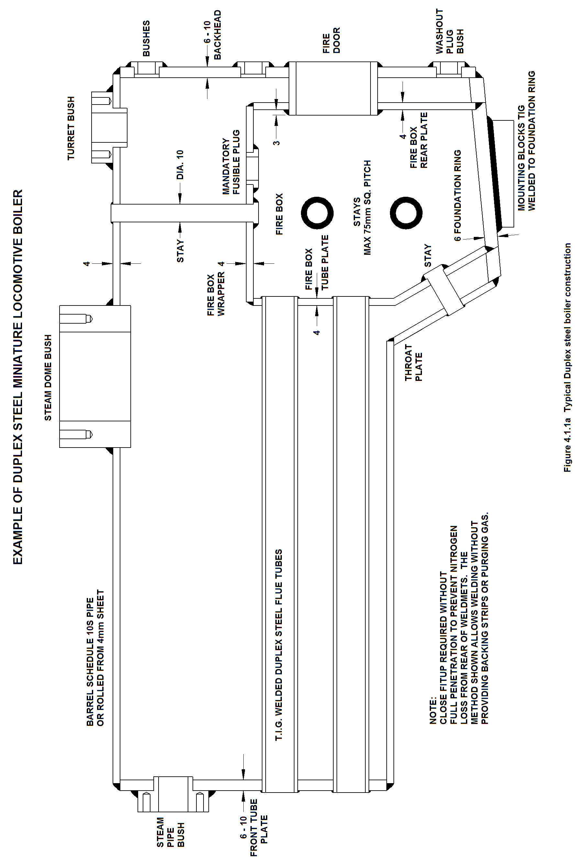
TYPICAL FIREBOX STAYS

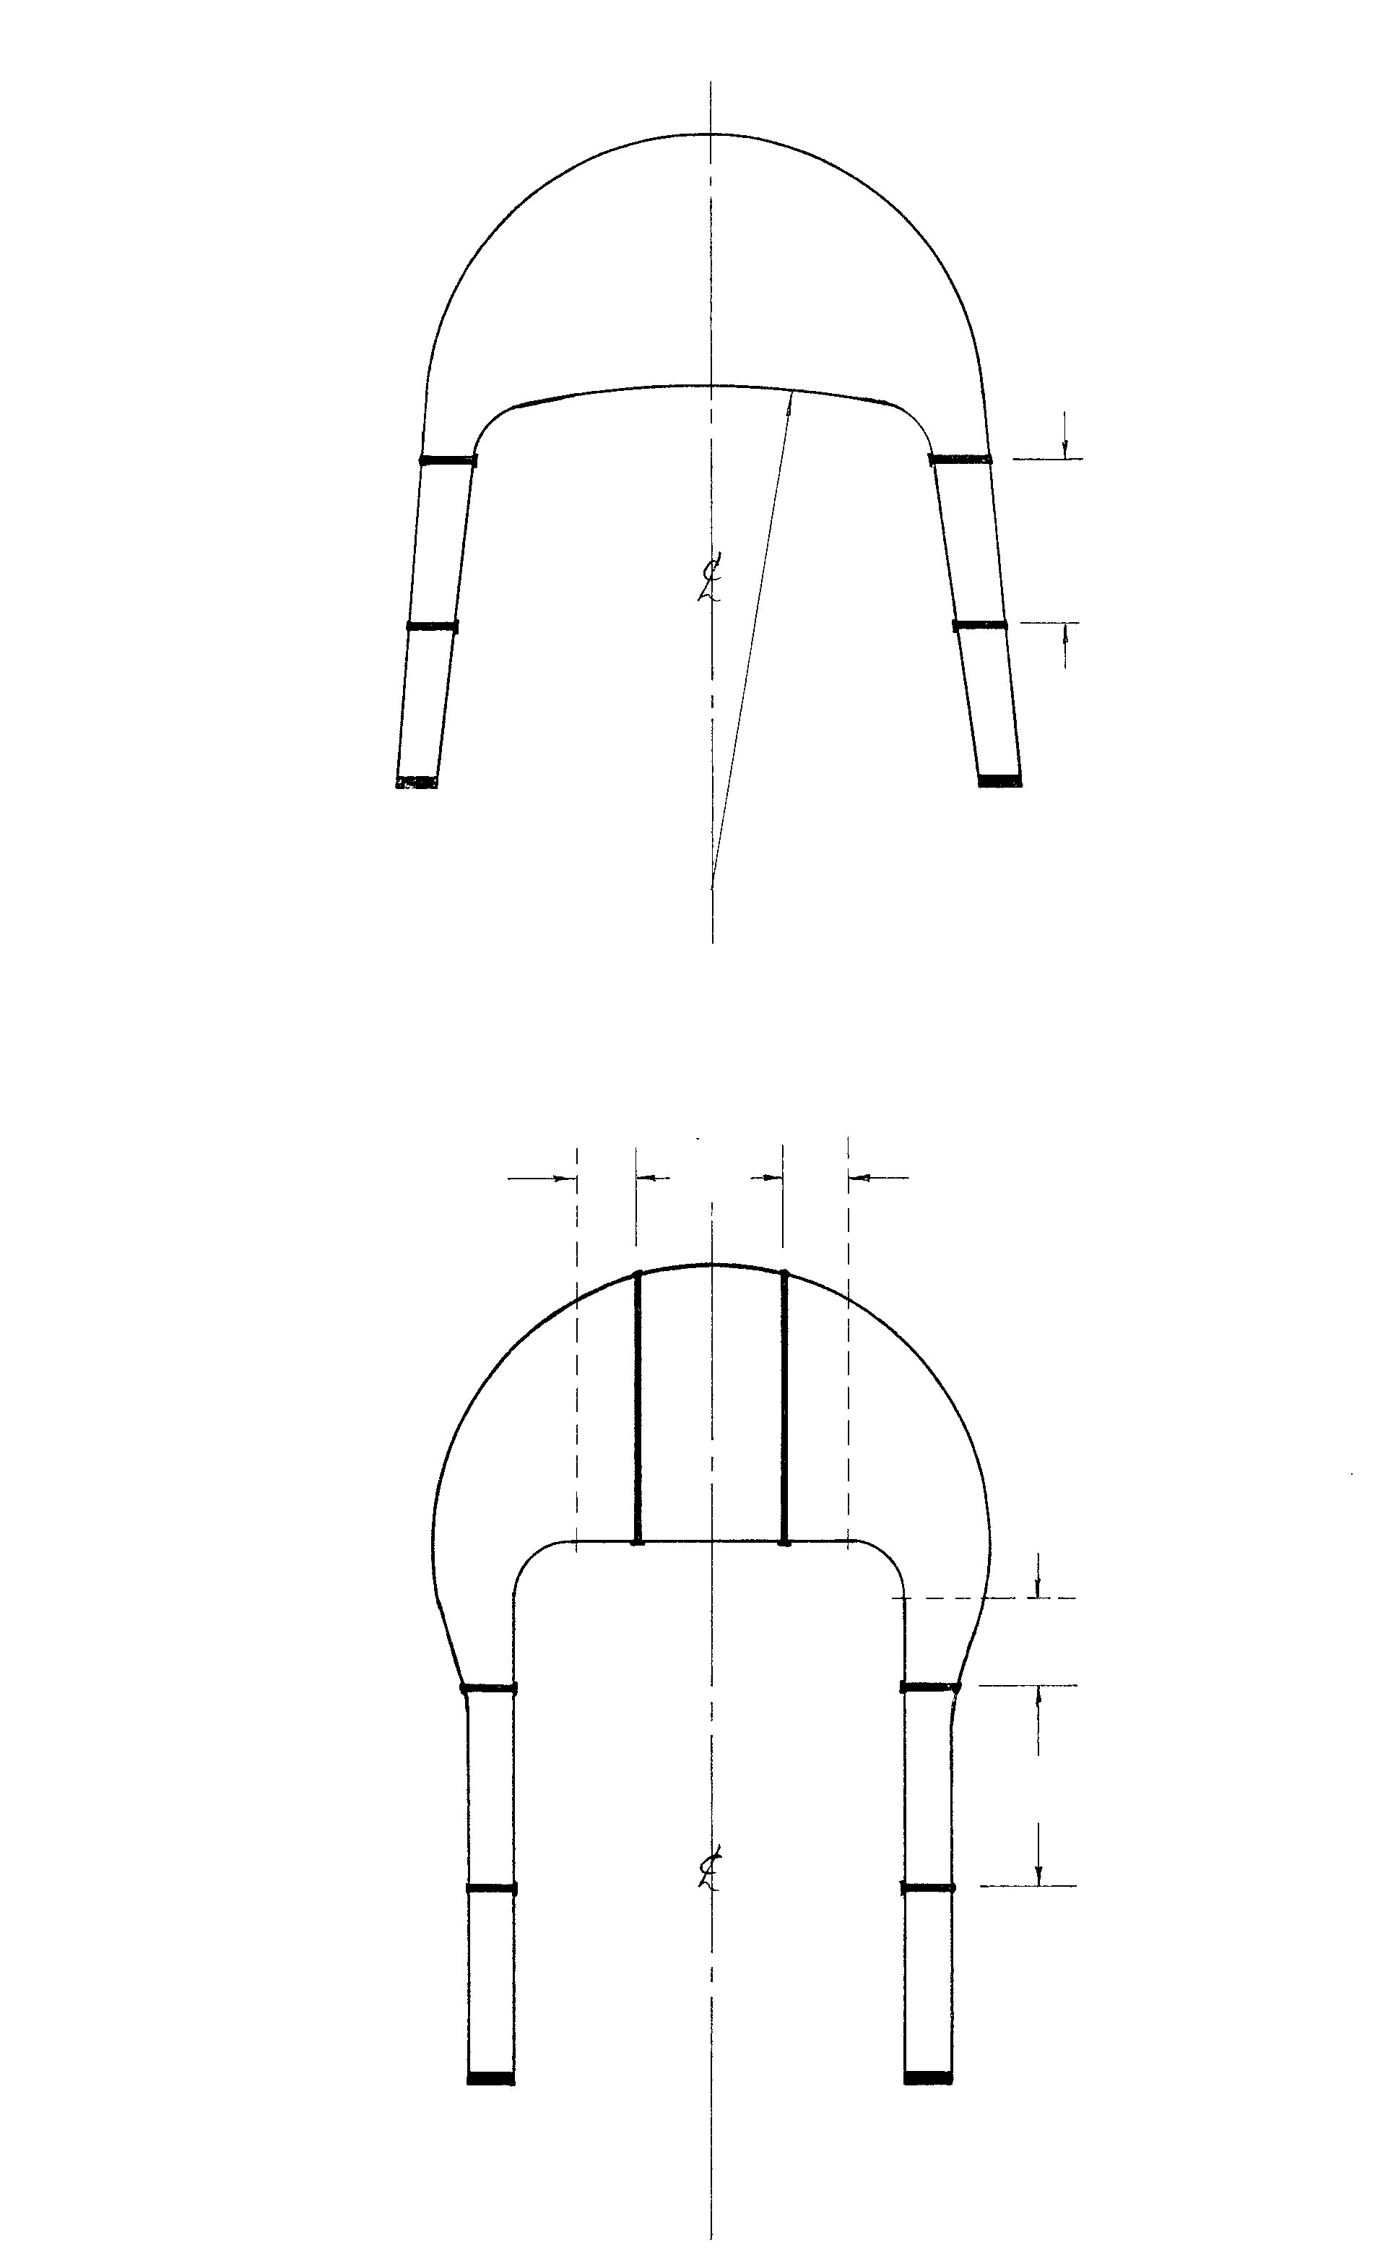
MAX 35
TANGENT POINT
TANGENT POINT
35
35
MAX
75
TANGENT POINT
MAX
75
MAX
75
FIREBOX CROWN RADIUS
= OUTER SHELL DIAMETER
NO CROWN
STAYS REQUIRED
MAX
Figure 4.1.2a Wide Firebox
Figure 4.1.3a Narrow Firebox
4.2 JOINT DESIGN

4.2.1 Typical GTAW (Gas Tungsten Arc Welded) joints for the construction of miniature Duplex steel boilers or air receivers are shown (Refer Page 17, Figure 4.2.1a).

    - GTAW (Gas Tungsten Arc Welded) lap joints shall be prepared as close fit-up joints and welded from one side.

    - GTAW (Gas Tungsten Arc Welding) of butt joints shall be full penetration weldmets (Refer welding procedure Page 6, Item 17).

4.3 GTA WELDING

4.3.1 GTAW (Gas Tungsten Arc Welding) shall be performed by a person in possession of an AS1796 welding certificate No.7 or, an industrial welder with more than two years current experience in the GTA welding of stainless steel who can demonstrate proficiency in the welding procedure outlined on pages 5 and 6 and, is working under the direct supervision of the holder of an AS1796 welding supervisor’s certificate (Certificate No.10 in AS1796).

4.3.2 FUSION WELDING PROCESSES OTHER THAN GTAW SHALL NOT BE USED.

4.3.3 Silver or bronze brazing filler metals shall not be used on any part of the Duplex steel boiler or pressure vessel.

 | PREPARATIONS | AS WELDED |  | AMPS
BUTT JOINT | 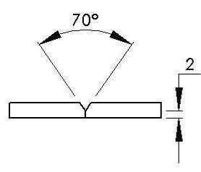 | 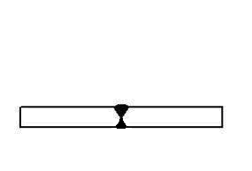 | 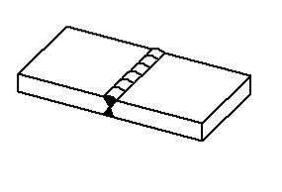 | 85-90A
4 X 4 LAP JOINT | 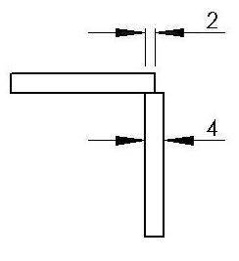 | 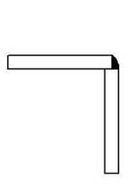 | 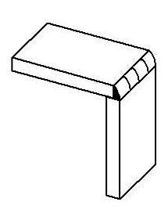 | 85-90A
4 X THICKER PLATE JOINT | 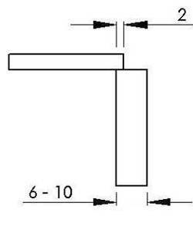 | 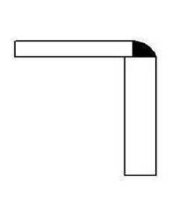 | 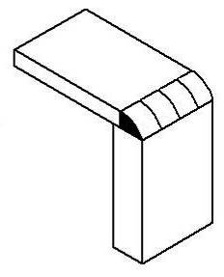 | 125-130A
TUBE TO TUBE PLATE | 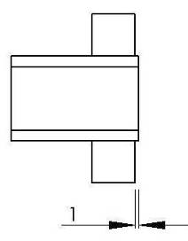 | 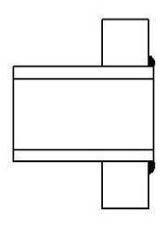 | 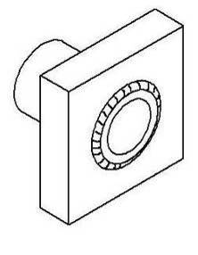 | 55-60A
STAYS | 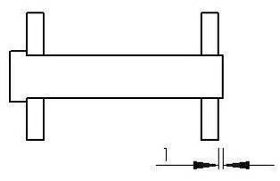 | 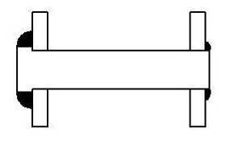 | 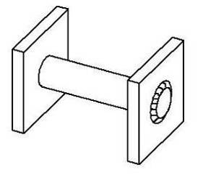 | 55-60A
BUSHES | 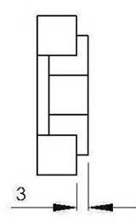 | 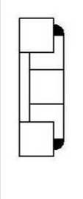 | 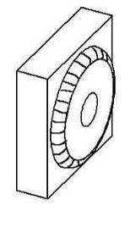 | 85-90A

Figure 4.2.1a
5. FITTINGS

5.1 SAFETY VALVES

5.1.1 All boilers and air receivers shall be fitted with at least one (1) safety valve, and where practicable, two (2) or more, according to prototype. Safety valves shall be connected as directly as possible to the boiler or air receiver, preferably directly to the shell or dome cover. Where, as in traction engines, safety valves are remote from the boiler, the passages shall have twice the cross sectional area of all valves and shall be incapable of isolation.

5.1.2 The diameter of safety valve orifices for boilers shall be found from the nomogram Figure 5.1.2. The diameter of safety valve orifices for air receivers shall be a minimum of 3 mm for air receivers with a volume of up to 5 litres, and a minimum of 4 mm for air receivers with a volume of 5 litres or more.

5.1.3 Recommended safety valve springs are shown in Table 5.1a These springs are for plain safety valves. Springs for pop type valves may be stiffer (fewer coils, larger wire or smaller diameter) than those given in the Table.

5.1.4 Safety valve springs shall be of a corrosion resistant material.

5.1.5 The exit vents from safety valve casings shall be at least equal to the area of the valve seat bore, and shall be unobstructed by springs or other internal parts.

5.1.6 All safety valves shall be provided with an effective means of locking the pressure adjustment after setting to the correct blow-off pressure. Figure 5.1.6 shows recommended methods of locking safety valve adjustment.

5.1.7 Safety valves shall be so constructed that it is impossible to lock the valve closed by means of the pressure adjustment.

5.1.8 Safety valves shall be provided with some means of "easing" the valve under pressure. eg. a lever or additional spindle length. Alternatively, it shall be possible to drop or extinguish the fire rapidly.

5.1.9 Ramsbottom safety valves shall be so constructed that breakage of the spring will not result in the loss of the cross lever or valves from the valve bodies.

VALVE DIAMETER | 4.8 | 5.5 | 6.3 | 7.1 | 7.9 | 8.7 | 9.5 | 10.3 | 11.1 | 11.9 | 12.7
Spring Rate (n/mm) | 2.2 | 3.1 | 3.8 | 4.1 | 4.5 | 4.9 | 5.4 | 5.9 | 6.3 | 6.8 | 7.2
 | Typical Spring Material Type 304 Stainless Steel
Outside Diameter (mm) | 6.3 | 7.4 | 8.4 | 8.4 | 10.2 | 10.2 | 11.4 | 10.4 | 12.7 | 11.4 | 13.5
Wire Diameter (mm) | 0.81 | 1.02 | 1.22 | 1.22 | 1.42 | 1.42 | 1.62 | 1.62 | 1.83 | 1.83 | 2.03
Active Coils | 12.5 | 11 | 13 | 11.5 | 11 | 10 | 11 | 13.5 | 11 | 15 | 12
Free Length (mm) | 22.9 | 23.1 | 29.7 | 29.9 | 33.0 | 32.2 | 37.1 | 41.9 | 41.4 | 49.3 | 47.7
Compressed Length at  700 kPa (mm) | 18.0 | 17.5 | 23.4 | 22.9 | 24.9 | 23.4 | 27.4 | 31.7 | 30.2 | 37.3 | 34.8

Table 5.1a - Safety Valve Springs - METRIC
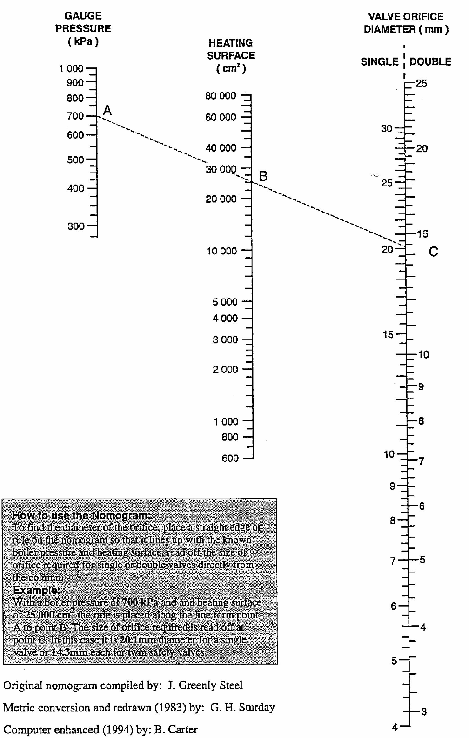
How to use the Nomogram
To find the diameter of the orifice, place a straight edge or ruler on the Nomogram so that it lines up with the known boiler pressure and heating surface, read off the size of orifice required for single or double valves directly from the column.

Example
With a boiler pressure of 700kPa and heating surface of 25,000 cm², the rule is placed along the line from point A to point B. The size of orifice required is read off from point C. In this case, it is 20.1mm diameter for a single valve or 14.3mm each for twin safety valves.

Figure 5.1.2 Safety Valve Orifice Nomogram
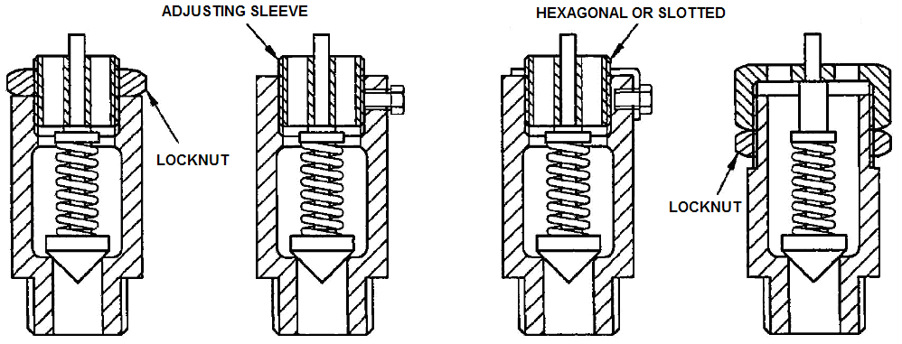
(a) Locknut (b) Setscrew (c) Tab and screw (d) Shellshear

Figure 5.1.6 Safety Valve Adjustment Suggested Locking Methods

5.2 PRESSURE GAUGES

5.2.1 All boilers and air receivers shall be fitted with a pressure gauge which has been tested against a pressure gauge of known accuracy. The gauge shall have a scale range of at least 20% (preferably 50%) in excess of the working pressure, and shall be indelibly marked ON THE DIAL FACE IN RED at the certified operating pressure.

5.2.2 Pressure gauges shall be connected to boilers via a water filled siphon.

5.2.3 Pressure gauges may be connected to air receivers directly or via pipe systems. Air receivers connected together in systems may be fitted with just one pressure gauge.

5.3 WATER GAUGES

5.3.1 Boilers shall be fitted with at least one (1) glass water level gauge. The bottom (visible) end of the glass shall be above the highest point of the crown of the inner firebox by not less than 10% of the distance from the crown to the outer wrapper.

Note: Consideration should be given to the variations in indicated water level that occur in long boilers on ascending and descending grades when determining the positions for water gauges.

5.3.2 Water gauges may be fitted directly to the boiler shell, or by extended pipes. Steam pipes to water gauges shall be arranged so that there are no pockets or hollows in which water can lodge. Hollow columns or pipes providing a connection between the water and steam pipes shall not be used.

5.3.3 Water gauges shall be connected to the boiler independently of all other fittings, including the steam manifold.

5.3.4 All passages in water gauges shall be not less than 3mm diameter.

5.3.5 The bottom connections of water gauges shall be provided with a minimum of 5mm clearance to internal parts of the boiler to ensure unrestricted flow.

5.3.6 Water gauges shall be fitted with a blow-down cock. Cleaning out plugs shall be provided opposite each passage into the boiler to allow the passages to be cleaned and proved clear.

5.3.7 Gauge glasses should be as long as possible, and they shall be visible to the driver from the normal operating position. Water gauges shall be mounted substantially vertically, and in no case at more than forty-five degrees (45°) to the vertical. Gauge glass protectors are recommended, particularly for larger boilers.

5.3.8 Boilers with a capacity greater than 25 litres shall be fitted with water gauge(s) of the three-cock type.

5.4 FEEDWATER SYSTEMS

5.4.1 Boilers for locomotives, traction engines and other mobile applications shall be equipped with at least two (2) independent means of supplying feedwater. These may be in the form of injectors, mechanical pumps, steam pumps, hand pumps, or any other method capable of supplying enough feedwater to maintain the boiler water level under normal operating conditions. Stationary and marine boilers shall be equipped with at least one (1) feedwater supply system.

5.4.2 Feedwater systems shall be connected to the boiler through a suitable check valve to prevent reverse flow of boiler water or steam to the feedwater system. Two or more feedwater systems may be connected to operate through a single check valve, provided each system has a check valve of its own to prevent flow from one system to the other.

5.4.3 Mountings for feed check valves may be placed anywhere on the boiler, but it is recommended that they be placed towards the front of the barrel, above the water level. Arrangements where incoming feedwater impinge on inner firebox plates should not be used.

5.5 BLOWDOWN VALVES

5.5.1 A boiler blowdown valve or drain valve shall be fitted at the lowest point of a boiler, where sludge and scale may accumulate. This valve or plug shall be readily accessible for washing out the boiler. Care shall be taken in the design and fitting of blowdown valves to ensure that they cannot inadvertently open during operation of the boiler.

5.5.2 Air receivers shall be fitted with a drain valve at the lowest point so that accumulated condensate may be removed.

5.6 WASHOUT PLUGS

5.6.1 Bushes shall be fitted with washout plugs, located as low as possible on the outer plates of the firebox.

5.7 FUSIBLE PLUGS

5.7.1 A fusible plug shall be fitted in the highest point of the inner firebox crown that is readily accessible for plug replacement.

5.7.2 The clear area through any fusible plug shall be equal to 20% of the area through the safety valves, with a minimum bore of 4mm diameter.

5.7.3 Fusible plugs shall be provided with fusible metal of commercially pure tin. Plugs may be completely filled with fusible metal, or with a copper slug sweated in place with fusible metal. Such slugs shall be able to pass freely from the fusible plug when the fusible metal melts. (Refer Figure 5.7)

5.7.4 Fusible plugs shall be designed so that the portion of the plug containing the fusible metal projects not less than 6mm into the water space. (Refer Figure 5.7)

    - Fusible plugs shall be removed and inspected or replaced at each quadrennial boiler inspection. Fusible plugs are ineffective unless kept clean on both the fire and water sides.

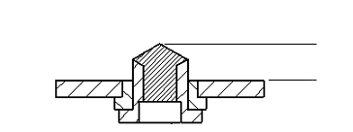
FUSIBLE METAL
6mm MIN
INCREASED BORE FOR FREE PASSAGE OF PLUG (IF USED)

Figure 5.7 Fusible Plugs

5.8 VALVES

5.8.1 Screw operated valves shall be fitted with a spindle and bonnet retaining device, to ensure that the valve stems cannot be screwed out under pressure.

5.8.2 Regulator valve levers and other vital control levers or hand wheels shall be positively secured to their spindles.

6. SUPPORT

6.1 Boilers for locomotives are normally fixed at the front (smokebox) end and usually require one of the following methods of providing expansion freedom, plus the necessary vertical restraints.

Figure 6.1 - Used on wide firebox boilers and/or long barrels
Figure 6.2 - An alternate to Figure 6.1, but with more limited movement
Figure 6.3 - For narrow fireboxes
Figure 6.4 - Traction engine cylinder mounting
Figure 6.5 - Traction engine horn plate stud mounting
Figure 6.6 - Traction engine horn plate channel stud mounting
Figure 6.7 - Traction engine horn plate circular cup stud mounting

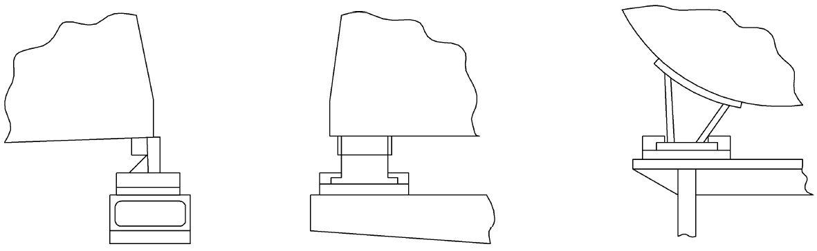
Firebox
Firebox
Side view
End view
End view
Boiler
barrel
FIREBOX BEARER
WAIST BEARER

Figure 6.1 Boiler Expansion Connection – Slider Type

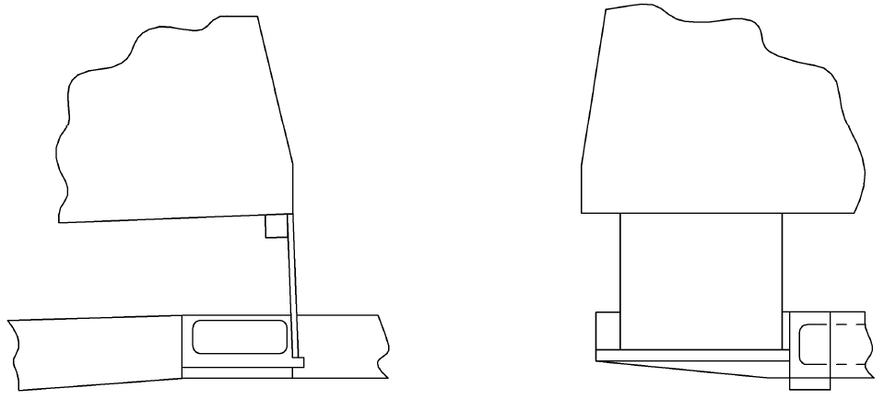
Firebox
Firebox
Side view
End view
FIREBOX BEARER

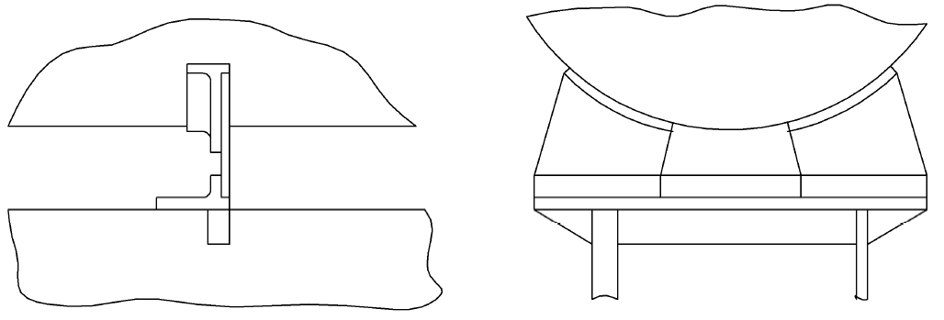
WAIST BEARER
Boiler barrel
Boiler barrel
Side view
End view
Frame
w

Figure 6.2 Boiler Expansion Connection – Diaphragm Type

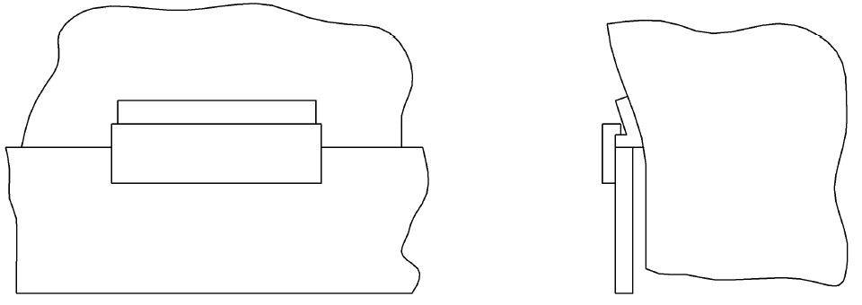
Keep, bolted to frame
Expansion
bracket
Keep
Figure 6.3 Boiler Expansion Bracket for Narrow Firebox

Note: Mounting brackets made from S31803 Duplex Steel or Carbon Steel to be GTAW welded to boiler shell using 22.8.3L consumables.

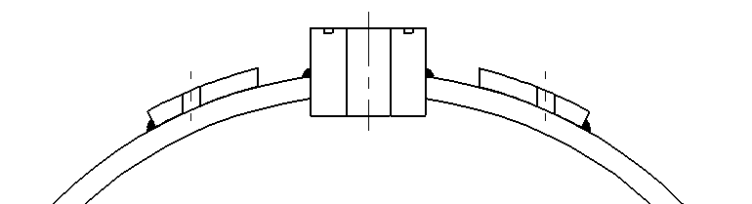
THREAD FOR MOUNTING STUDS
DUPLEX STEEL BOILER BARREL
CARBON STEEL CYLINDER MOUNTING PLATE GTAW ALL ROUND TO BOILER BARREL
DUPLEX STEEL CONNECTING BUSH WITH ‘O’ RING SEAL

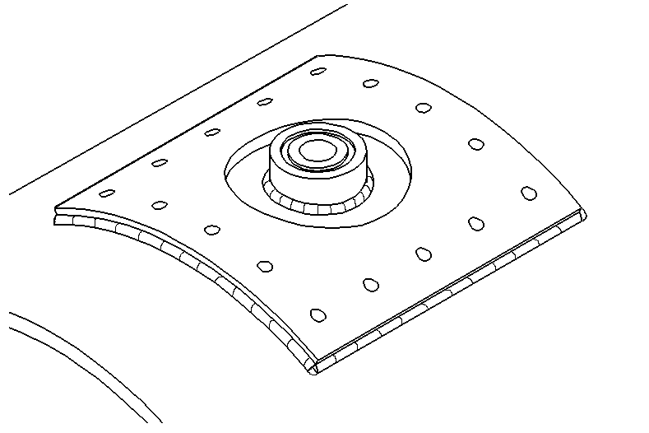
BOILER BARREL

Figure 6.4 Carbon steel traction engine cylinder mounting and compensation plate

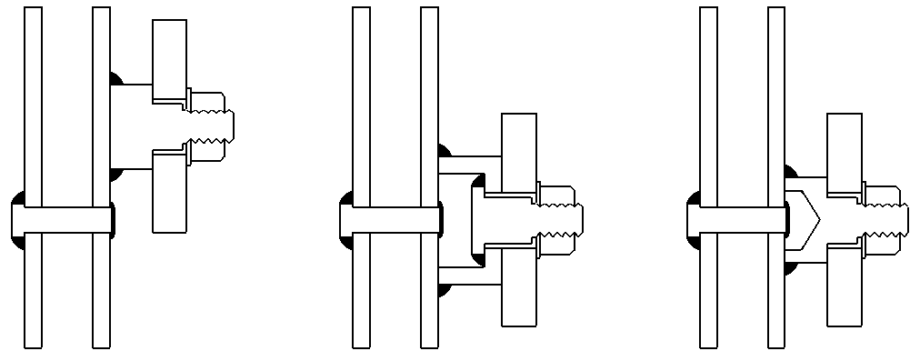
FIRE SIDE WATER LEG
HORN PLATE
STAY
STAY
STAY
NOTE: -
SHOULDER TO PENETRATE HORN PLATE 80-90%
FIRE SIDE WATER LEG
FIRE SIDE WATER LEG
HORN PLATE
HORN PLATE

Figure 6.5 Figure 6.6 Figure 6.7
Stud mount Channel mounting Circular cup
to clear stay stud mounting
7. INSPECTION AND TESTING

7.1 INSPECTION

7.1.1 Inspection and testing shall be carried out by an AMBSC boiler inspector of the club issuing the certificate. See Appendix 1 for details of qualifications required by AMBSC boiler inspectors.

7.1.2 The designer, builder or owner shall not inspect or certify their own boiler or air receiver, but should be present during testing.

7.1.3 Each club shall maintain a boiler record book, which is available from the AMBSC Secretary. Each individual entry should be entered in numerical order. The boiler record book remains the property of AMBSC, and may be examined by an AMBSC Officer upon reasonable request. See also Clause 10.2.1.

7.1.4 Each boiler shall be given an identification number which will indicate the State, club, year of construction and serial number, as shown below;

(State) N, (club) A, (year) 08, (serial number) 01
ie, NA 08 01

Each air receiver shall be given an identification number which will indicate the State, club, year of construction, serial number and an identifier as an air receiver, as shown below;

(State) N, (club) A, (year) 08, (serial number) 02, (air receiver) AR
ie, NA 08 02 AR

This number shall be stamped on the boiler or air receiver by the inspector after a satisfactory hydrostatic test or after rejection (Refer Section 7.4).

7.1.5 The identification number shall be so located on the finished boiler or air receiver so that it can be checked by a boiler inspector without difficulty when the boiler installation is complete. Marking shall be permanent and shall be located on the dome ring, the foundation ring, or on a small plate GTA welded to the vessel, preferably on the backhead above the firehole door. This blank identification plate shall be GTAW to the boiler during construction.

7.1.6 It is recommended that, where possible ONE inspector carries out all inspection and testing during the construction of a boiler or air receiver.

7.1.7 Inspection shall be carried out during and after construction, in accordance with this Code to;
a) Verify the design,
b) Confirm the suitability of the materials,
c) Assess the suitability of all parts before joining,
d) Confirm the suitability of the joining process
e) Confirm compliance with hydrostatic test requirements,
f) Prove the safe working of the boiler or air receiver.

7.1.8 Stages of inspection shall be as follows;

a) Prepared plates and tubes together with welding consumables.

b) Finished boiler or air receiver, (construction only)

7.2 TESTING

7.2.1 All new boilers and air receivers shall be subjected to a hydrostatic test to maximum 1¼ times working pressure (WP x 1.25). The test pressure shall be maintained for not less than 10 minutes, during which time checks are to be made for leakage.

7.2.2 The pressure gauge shall be tested against a master gauge of known accuracy, and a line marked on the DIAL FACE IN RED, to indicate the working pressure. The gauge should be re-checked after marking.

7.2.3 Boilers shall be subjected to the following additional tests.

7.2.4 A steam test shall be carried out during which the safety valves shall all be set and locked at the working pressure. During this test the operation of the feed water arrangements shall be checked, and also the means of rapidly dropping or extinguishing the fire.

7.2.5 Water level gauges shall be checked for correct function by operating the gauge blow-down cock and observing the water level. The level should return quickly to its original level after blowing down.

7.2.6 Following the test in Clause 7.2.4, an accumulation test shall be carried out. The boiler is to be steamed, as far as possible under full firing conditions, and the water level observed from full glass to near empty (visible) glass. During this test, the safety valves should be lifting, and at no time shall the pressure rise above the set working pressure P + 10%.

(For superheater protection, the engine should be spragged and set in fore or back gear with the regulator cracked and the cylinder drains open, or with the wheels turning slowly).

7.2.7 Air receivers shall be subjected to the following additional tests.

7.2.8 A safety valve functional test shall be carried out during which the safety valves shall be set and locked at the working pressure.

7.2.9 Safety valve accumulation shall be tested by operating the compressed air supply system at full capacity. At no time shall the pressure rise above the set working pressure P + 10%. Upon satisfactory completion of these tests, an air receiver certificate is issued with no further testing required.

7.2.10 Upon satisfactory completion of all tests, a boiler certificate shall be issued for a period of one (1) year and shall be signed by the clubs boiler inspector. The boiler inspector's name shall be both signed and legibly printed on the boiler certificate. The signature of a witness to testing is optional, at the discretion of the club or society.

Note: A boiler or air receiver is deemed to be registered upon hydrostatic testing and stamping.

7.3 RETESTING

7.3.1 On expiry of one year, a retest shall be carried out including internal inspection, to the satisfaction of the boiler inspector. This test shall consist of a hydrostatic test to P x 1.25, a check of all gauges, and an accumulation test as in Clauses 7.2.6 or 7.2.9. The boiler shall be prepared according to the instructions of the boiler inspector, with inspection covers and plugs removed if required. Water gauge fittings shall have all cleaning plugs removed for examination of the passages. Following satisfactory completion of these tests, a new certificate shall be issued for a further period of four (4) years. Subsequent testing shall be carried out quadrennialy.

7.3.2 In the event of any major repairs or re-build, a hydrostatic test to P x 1.25 shall be carried out, followed by an accumulation test as in Clauses 7.2.6 or 7.2.9.

7.3.3 A boiler that has been out of service for a period in excess of twelve (12) months shall be submitted to a boiler inspector for a safety check to ensure that the boiler fittings are still functioning correctly.

7.3.4 Removal of insulation, or the boiler from its mountings, for the purpose of inspection, is at the discretion of the boiler inspector. This would normally only be carried out if the boiler is suspect in any way, or if a major repair has been carried out.

7.4 REJECTION

7.4.1 In the event of a boiler or air receiver being rejected after registration and identification, or rejected during construction, the boiler inspector shall notify the AMBSC Hon. Secretary within thirty (30) days. This is to discourage any person submitting the boiler or air receiver to another club boiler inspector for eventual certification. See also Clause 7.4.3.

    - An entry shall be made in the appropriate boiler record book to indicate that the boiler or air receiver has been rejected. The identification number shall be stamped on the boiler or air receiver in accordance with clauses 7.1.4 and 7.1.5.

    - In the event of rejection of a boiler or air receiver by a boiler inspector, the owner and/or builder shall have the right of appeal to the AMBSC in writing.

- IMPORTED BOILERS

The importer or owner of a commercial boiler constructed without the supervision of an AMBSC-registered model club shall satisfy the relevant State Regulatory Authority that the boiler meets the requirements of this Code, and has been constructed and tested under the supervision of an acceptable overseas inspection Organisation.

- OPERATION

9.1 WATER QUALITY

Duplex Steel boilers are considered free of corrosion problems; however to prevent a build up of sediment, it is recommended that advice be sought from competent water treatment advisers on the use of a suitable flocculant agent, to assist in the removal of solids during blowdown.

  - WATER LEVEL

    - The gauge glasses shall be clean and visible from the usual operating position and the connections to the boiler shall be clear. To check that they are clear, open and close the gauge glass blow-down cock(s). The water level should drop out of sight and then rise promptly to the previous level. Alternatively, rock the engine on its springs and the water level should move up and down in the glass. A still water level is probably a false one. Gauge glasses with three cocks shall be tested by blowing through each passage in turn.

    - The water is said to “swell” in the gauge glass when the regulator is opened and steam bubbles form below the water level. This swell may increase the water level by half a glass or more. Conversely, when the regulator is closed the level drops and this must be allowed for when travelling over a summit.

  - RAISING STEAM

    - Fill the boiler to working level. Check that all steam, water and blowdown valves are free to operate and close them gently onto their seats. Check that gauge glass cocks are free to turn.

9.3.2 Raise steam with wood, kerosene or other preferred fuel. Draught is normally provided with a chimney fan or compressed air jet. The engine's blower is used when steam pressure is high enough. (Typically 140 kPa, or 20 psi.).

9.3.3 Before leaving the depot, check the operation of the following:

- Gauge glasses
- Safety valves
- Injectors. These should pick up and work without dribble from the overflow. Injector trouble is most likely due to an air leak, air lock or restriction on the suction side.
- Hand and axle driven pumps. The delivery lines next to the feed check valves (clacks) will be cold when the pumps are delivering water.
- Brakes
- Whistle

9.4 LOSS OF WATER OR OTHER INCIDENTS

9.4.1 In the event of loss of water in any boiler, stop the engine and shut off the blower immediately. The procedure to be followed depends on how long the water has not been visible. If the water shows in the gauge glass on opening and shutting the drain cock, the feed may be safely put on. Do not rock the engine as this may splash water onto an overheated plate.

9.4.2 If no water appears in the gauge glass or the fusible plug melts, it is essential to dispose of or douse the fire. When the design allows the fire to be dropped rapidly, this should be done. It is unwise to rake or disturb the fire, and if it cannot be dumped it should be smothered with water or by blocking the chimney and turning on the blower which forces condensing steam to reduce the fire. It is highly desirable that boilers be fitted with a dumping grate.

9.4.3 In the event of an accident to the machine carrying the boiler, or the failure of a fusible plug, or failure of any part of a boiler (except the gauge glasses), or any other incident likely to have caused damage to a boiler, notification shall be made to an AMBSC boiler inspector of the certifying club before any attempt is made to further operate the boiler. The extent of the examination to be conducted by the boiler inspector in such cases is at the discretion of the boiler inspector. Prior to the commencement of any repairs, the extent and method shall be discussed with and approved by the boiler inspector.

9.5 SHUTTING DOWN

9.5.1 Dispose of the fire.

9.5.2 Allow the boiler to cool until a pressure of around 140 kPa (20 psi.) remains, and then blow the boiler down through the blow-down valve(s).

10. ADMINISTRATION

10.1 REGISTRATION OF NEW CLUBS OR SOCIETIES

10.1.1 Compliance with the following basic rules is required prior to any club or society being accepted for registration with the AMBSC, in accordance with the current requirements of the Australian Association of Live Steamers.

- A club or society shall have a minimum number of 10 fully paid up members.

- Names, addresses and telephone numbers of the President and Secretary are required.

- Names, addresses and telephone numbers, qualifications and experience of the proposed boiler inspectors are required.

- A written assurance is to be submitted that the proposed club constitution and rules shall include the provision that "no pressure vessel shall be operated within the club's jurisdiction without a current, valid pressure vessel certificate".

10.2 WINDING UP

10.2.1 In the event of any club that is affiliated with and operating to the AMBSC Codes winding up its activities, the boiler record books shall be returned forthwith to the AMBSC Secretary for further reference.

10.3 CHANGE OF OWNERSHIP OR DISPOSAL OF A BOILER OR AIR RECEIVER

10.3.1 In the case of change of ownership the following procedures shall apply;

a) The original identification number shall be retained.

b) A new certificate shall be issued in the name of the new owner for any un-expired period of currency.

10.3.2 If the certificate has expired, the boiler or air receiver shall be re-inspected in accordance with Clause 7.3.

10.3.4 If the change of ownership does not involve a change of club, the details of the new owner shall be entered in the club boiler record book.

10.3.5 If the change of ownership does involve a change of club, the new certificate shall be issued by, and in the name of the club, to which the new owner belongs. The entry in the new owner's club boiler record book shall contain a reference to the original owner and to the club issuing the original certificate. A copy of the original boiler record book pages from the original issuing club shall be attached to the new record.

10.3.6 Copies of the original construction drawings, if available, shall be transferred to the new owner.

10.3.7 To obviate interference with the sequence of identification numbers in a club's boiler record book changes of ownership may be entered starting from the back of the book.

APPENDIX 1

AMBSC Boiler Inspector Qualifications

A1.1 ACCEPTABLE QUALIFICATIONS FOR APPOINTMENT AS AN AMBSC BOILER INSPECTOR

A1.1.1 A person holding a tertiary qualification issued by an accredited university, college, or government agency, such qualification being in a field related to the design, testing, and operation of pressure vessels, or;

A1.1.2 A competent model boiler constructor who shall possess the following criteria to be eligible;

- A minimum educational qualification of a NSW Higher School Certificate, or equivalent, or a trade certificate, or higher qualification, and

- A minimum of three years membership of an AMBSC registered society, and

- The successful construction of at least one miniature boiler, and

- A minimum of two years experience in the practical operation of miniature boilers, and

- Two current boiler inspectors to act as referees to attest to the satisfactory quality of workmanship of the nominee inspector.

APPENDIX 2

EXAMPLES OF AMBSC FORMS

AUSTRALIAN MINIATURE BOILER SAFETY COMMITTEE
BOILER CERTIFICATE

Issued by : (Club)
Issued to : (Name)
Boiler identification :
Approved working pressure : kPa
Date of issue :
Date of expiry :
Boiler fitted to :

Signed : Boiler Inspector

Signed : Witness

AUSTRALIAN MINIATURE BOILER SAFETY COMMITTEE
BOILER RECORD

Issued by :

General Details
Builder :
Owner :
Club :
Identification :
Design Pressure (P) : kPa
General Description (Indicate new or existing boiler) :

Application :

Design Details (Drawing number and details to be set out below) :

Construction Check
Platework Date of approval :
Signed :
Signed :

Welding consumables Date of approval :
Signed :
Signed :
For copper boilers only

Firebox and tube Date of approval :
Assembly (Brazed up) Signed :
Signed :

Boiler shell and Date of approval :
Wrapper assembly Signed :
Signed :
Finished boiler
(construction only) Date of approval :
Signed :
Signed :

AUSTRALIAN MINIATURE BOILER SAFETY COMMITTEE
BOILER TEST RECORD

Hydrostatic test (P x 1.25) : kPa (P x 2) Copper : kPa
Duration : minutes
Date :
Notes :
Signed : Inspector :
Signed : Witness :

Steam test (normal firing conditions)
Pressure gauge :
Safety valves :
Water gauge :
Duration, high to low water level : minutes
Pressure accumulation (full firing conditions) : kPa max
Date :
Signed : Inspector :
Signed : Witness :

Certificate issued
From : To :
Signed : Inspector :
Signed : Witness :

Certificate reissued
From : To :
Notes :
Signed : Inspector :
Signed : Witness :

Certificate reissued
From : To :
Notes :
Signed : Inspector :
Signed : Witness :

Certificate reissued
From : To :
Notes :
Signed : Inspector :
Signed : Witness :

APPENDIX 3

AMBSC Registered Societies

The following societies and their respective Identification Codes were registered with the Australian Miniature Boiler Safety Committee as at 30th. June 2006.

Name ID Code
Australian Capital Territory (prefix A)
Canberra Society of Model and Experimental Engineers (Ident was NL)…………………… AA

New South Wales (prefix N)
Sydney Live Steam Locomotive Society Co-op Ltd……………………………………………. NA
Sydney Society of Model Engineers Inc………………………………………………………… NB
Illawarra Live Steamers Co-op Ltd………………………………………………………………. NC
Lake Macquarie Live Steam Locomotive Co-op Society Ltd………………………………….. ND
Blue Mountains Railway Co-op Ltd……………………………………………………………… NE
Bankstown Steam Locomotive Society Co-op Ltd……………………………………………... NF
Western districts Live Steamers Co-op Ltd……………………………………………………... NG
South Coast Model Engineering Society Co-op Ltd (Club disbanded)………………………. NH *
Border Steam & Oil Engine Club (now Lake Hume Model Engineers Inc)………………….. NI *
Hornsby Model Engineers Co-op Ltd……………………………………………………………. NK
Canberra Society of Model and Experimental Engineers (Ident changed to AA)…………... NL *
Bathurst Miniature Railway Society Co-op Ltd…………………………………………………. NM
Wagga Wagga Society of Model Engineers Inc………………………………………………... NN
Central Coast Steam Model Co-op Ltd………………………………………………………….. NO
Orange Society of Model Engineers Inc………………………………………………………… NP
Mudgee Miniature Railway Co-op Society Ltd………………………………………………….. NR
Great Northern Railway (Club disbanded)……………………………………………………… NS *
Maritime Model club of NSW Inc…………………………………………………………………. NT
Ridge Narrow Gauge Railway……………………………………………………………………. NU
Pacific Coast Railway Society Inc……………………………………………………………….. NV *
St George Model Boat Club Inc………………………………………………………………….. NW
Berry Railway Inc………………………………………………………………………………….. NX
Tweed Valley Miniature Steam Railway………………………………………………………… NY
Twin Lakes Railway (Club disbanded)…………………………………………………………... NZ *
Lake Forbes Model Club Inc (Club disbanded)………………………………………………… N2A *

* Indicates society no longer in operation, registration withdrawn, or registration name or details changed
Southern Highlands Model Engineers Inc………………………………………………………. N2B
Richmond River Miniature Railway and Model Engineers (Club disbanded)……………….. N2C *
Museum Leeton……………………………………………………………………………………. N2D
Jerilderie Steam, Rail & Heritage Club………………………………………………………….. N2E
Penwood Railroad Inc…………………………………………………………………………….. N2F
Ravenglass Light Railway………………………………………………………………………… N2G
Timbertown Miniature Railway & Model Engineering Society………………………………… N2H
Holbrook Miniature Railway Society Inc………………………………………………………… N2J
Tamworth & District Model Engineers Inc………………………………………………………. N2K
Rails in the Garden Inc……………………………………………………………………………. N2L

Victoria (prefix V)
The Steam Locomotive Society of Victoria Inc…………………………………………………. VA
Melbourne Society of Model and Experimental Engineers (not registered)…………………. VB *
Loddon Miniature Steam Locomotive Society Inc (was Victorian Min S L Soc)…………….. VC *
Springvale Live Steamers………………………………………………………………………… VE
Diamond Valley Railway Ltd……………………………………………………………………… VF
Tullamarine Live Steamers Locomotive Society……………………………………………….. VG
BHP Westernport Railway Society (now Bluescope Steel Westernport RS)……………….. VH *
Altona Miniature Railway Inc……………………………………………………………………... VJ
Lake Hume Model Engineers Inc (was Border Steam & Engine Club)……………………… VK *
Mooroolbark and District Miniature Railway and Steam Club………………………………… VL
Box Hill Miniature Steam Railway Society Ltd………………………………………………….. VM
Ballarat Society of Model Engineers Inc………………………………………………………… VN
Gippsland Model Engineering Society Inc………………………………………………………. VO
Wandong Live Steamers Inc……………………………………………………………………… VP
Geelong Society of Model and Experimental Engineers………………………………………. VR
Euroa Steam Locomotive and Model Engineering Society Inc……………………………….. VS
South Western (Vic) Model Engineers Inc……………………………………………………… VT
Wimmera Live Steam & Model Engineers Society Inc………………………………………… VU
Bendigo Society of Model Engineers……………………………………………………………. VW
Campaspe Valley Railway Inc……………………………………………………………………. VX
Gisborne Vintage Machinery Society……………………………………………………………. VY
Nhill Miniature Railway (Club disbanded)……………………………………………………….. VZ *

* Indicates society no longer in operation, registration withdrawn, or registration name or details changed
South Australia (prefix S)
South Australian Society of Model and Experimental Engineers Inc………………………… SA
Whyalla Society of Model Engineers (Club disbanded)……………………………………….. SB *
Morphett Vale Railway Inc………………………………………………………………………... SC
Penfield Model Engineers Society……………………………………………………………….. SD
Adelaide Miniature Steam Railway Society Inc………………………………………………… SE
Roseworthy Live Steam Model Railway Inc…………………………………………………….. SF
Paris Creek Railroad (Club disbanded)…………………………………………………………. SG *
Port Augusta Model Engineers Inc………………………………………………………………. SH
Clare Valley Model Engineers……………………………………………………………………. SK

Queensland (prefix Q)
Queensland Society of Model and Experimental Engineers Inc……………………………… QA
MELSA Maryborough Inc…………………………………………………………………………. QB
Mackay Society of Model Engineers Inc………………………………………………………… QC
Sunshine Coast Railway Modellers Society Inc………………………………………………... QD
Toowoomba Live Steamers Inc………………………………………………………………….. QE
MELSA Rockhampton…………………………………………………………………………….. QF
Leichardt River Railway Model Engineers Society (Club disbanded)………………………... QG *
MELSA Gladstone…………………………………………………………………………………. QH
South East Queensland Live Steamers…………………………………………………………. QJ
Townsville and District Society of Model Engineers Inc……………………………………….. QK
Logan Model Engineering Society Inc…………………………………………………………… QL
MELSA Bribie Inc………………………………………………………………………………….. QM
Brisbane Live Steamers and Model Engineers (now Brisbane Bayside Society Inc)……… QN *
Grandchester Model Live Steam Association Inc……………………………………………… QP
Redland Model Engineers Inc……………………………………………………………………. QR

Tasmania (prefix T)
North West Model Engineering Society…………………………………………………………. TA
Hobart Miniature Steam Locomotive Society Inc………………………………………………. TB
Evandale Light Railway and Steam Society……………………………………………………. TC

* Indicates society no longer in operation, registration withdrawn, or registration name or details changed
Western Australia (prefix W)
Castledare Miniature Railway…………………………………………………………………….. WA
West Australian Model Engineers Club Inc……………………………………………………... WC *
Great North West Model and Miniature Railway Society Inc…………………………………. WD
South West (WA) Model Engineers Association……………………………………………….. WE
Northern Districts Model Engineering Society (Perth) Inc…………………………………….. WF
Katanning Miniature Railway……………………………………………………………………... WG
Toodyay Miniature Railway……………………………………………………………………….. WH
Batavia Coast Minature Railway Society………………………………………………………... WJ

* Indicates society no longer in operation, registration withdrawn, or registration name or details changed
APPENDIX 4

Typical Design Submission Requirements for Regulatory Authority Design Registration

The requirements for design registration in most states are:

- Submission of a completed design registration application form.

- Submission of one copy of the general arrangement drawing of the item of plant.

- Payment of the appropriate application fee.

Once the design has been accepted and registered, a design registration document will be returned to the applicant nominated in the application form. This document will not contain any special manufacturing requirements; these will be specified by the designer, the design verifier and the fabrication inspector.

The design registration number assigned in this document must then be stamped on all vessels constructed to this particular design.
APPENDIX 5

Commercial Supply

UNS S31803 is a tough material and it is recommended that the constructor seek professional assistance in the construction of Duplex Steel pressure vessels.

Press shaping and rolling of UNS S31803 will generally require professional expertise and equipment. Cold working only should be used when shaping or bending UNS S31803.

Sandvik in Sydney can program from detailed component drawings; and are prepared to laser-cut components from SAF2205 sheet.

Each component will be laser engraved as proof of material type.

Sandvik will supply and cut to length SAF2205 Schedule 10 pipe over 50mm in diameter.

SAF2205 Domes, Bushes, and Stays in standard sizes together with a material type certificates can be supplied by:

KAJMAC Holdings Pty Ltd Peter Glover Engineering Pty Ltd Dinki Di Engineering Pty Ltd
Unit 6, 61-63 Batt Street 34A Ascot Road 13 Dorset Street
Penrith, NSW, 2750 Bowral, NSW, 2756 Lonsdale, SA, 5160
Phone: (02) 4721 3566 Phone: 0429 998 632 Phone: (08) 8382 5522
APPENDIX 6 (for copy purposes)

Suggested Welding Sequence for a Miniature Locomotive Boiler

1. Degrease all boiler components with detergent, wash, rinse and allow to dry.

2. Check fit-up of each component and that all holes align with a neat sliding fit

3. Weld full-penetration butt joints if fabricating barrel

4. Weld throat plate to barrel

5. Weld outer firebox wrappers to barrel and throat plate

6. Position front tube plate and firebox tube plate.
Insert flue tubes and tack weld a few flue tubes to position and hold tube nest

7. Withdraw tube nest and proceed to step weld tubes to tube plates

8. Narrow firebox wrapper, if made in two halves for ease of bending, shall require a full-penetration longitudinal butt weld

9. Weld firebox wrapper to firebox tube plate

10. Weld vertical stay heads to firebox wrapper crown

11. Weld fusible plug bush to crown of firebox wrapper

12. Weld fire hole tube to rear firebox plate

13. Weld rear firebox plate to firebox wrapper

14. Insert tube nest and firebox into barrel. Weld side stays and vertical stays to barrel

15. Tack weld foundation ring

16. Weld front tube plate to barrel

17. Weld and fit steam pipe and bushes in place

18. Weld back head in place

19. Weld firebox door tube

20. Weld foundation ring

21. Weld dome and remaining bushes

22. Weld mounting blocks in place

23. Pickle and clean up welds

APPENDIX 7 (for copy purposes)

Welding Procedure for Miniature Boilers and Air Receivers

- A copy to be given to welder before commencement of welding.

- Welding shall only be gas tungsten arc welding (GTAW) commonly known as TIG welding, to AS1167.2

- All welding shall be performed by persons certified in accordance with AS1796 for pressure vessel welding, or by persons under direct supervision of a welding supervisor certified in accordance with AS1796.

- Welding quality Argon shall be used for all GTAW weldmets per AS3992, clause 2.2 “pre-qualified gases”.

- Suggested Argon flow rate of 8-9 litres/min.

- Welding polarity DC negative to torch.

- Thoriated Tungsten electrode diameter 2.5mm.

- Welding consumables shall be 2.5mm diameter Sandvik type 22.8.3.L or equivalent.

Note: No other consumables to be substituted under any circumstance. The welding consumables are to be verified by boiler inspector and then supplied to the welder by the owner; reinforcing the requirement that no substitution of consumables is allowed.

- Work area to be clean and free of contaminants.

- Degrease boiler components in detergent, rinse with clean water and allow to dry.

- New, clean, stainless steel grinding wheels are only to be used for any grinding to avoid contamination of duplex steel or weldmet.

- Tack weld approximately 100mm apart or as required.

- All tack welds to be ground out before welding over tack area.

- Ensure a tight fit-up with a minimum of 2mm lap for welding of joints 85-90A and 125-130A (Appendix 8). This allows a weldmet without the need of backing strips or purging gas. This tight fit-up is important as this method prevents the loss of nitrogen from the back of the weld.

- Full penetration is to be avoided on all lap joints. The currents suggested with each type of weld should achieve approximately 1mm penetration.

- If full penetration occurs, the back of the weld shall be ground out and a capping run over the ground area. Strongly suggest fabricating test pieces from scrap and proving penetration depth prior to welding of pressure vessel.

- Longitudinal and circumferential butt welds, 85-90A shall be close fit up and welded along prepared joint; followed by a capping run to rear of the weld to provide a full penetration weldmet.

Alternatively, to achieve a full penetration weld from one side:

- Provide Argon purging gas to rear of weld
- Provide 1mm root gap
- Weld full-penetration root run (key hole method)
- Weld capping run

- Flue tubes to protrude 1mm though tube plate. Start weld with the addition of filler rod then complete weld by melting the tube end over into the tube plate. Use step-weld sequence and alternate between front and rear tube plates to reduce sheet distortion.

- Stay ends to protrude 1mm past sheet surface. Start weld with the addition of filler rod then complete weld by melting end of stay over into the sheet. This is sometimes known as a “rosette” weld.

- It is mandatory that all welds are finally pickled and scrubbed with a clean stainless steel wire brush followed by thorough rinsing.

- It is important to follow the manufacturers’ instructions and safety guidelines together with correct procedures in disposal of these chemicals.

APPENDIX 8 (for copy purposes)

Gas Tungsten Arc Welded Joints for Miniature Boilers and Air Receivers

 | PREPARATIONS | AS WELDED |  | AMPS
BUTT JOINT | 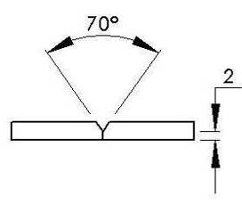 |  |  | 85-90A
4 X 4 LAP JOINT | 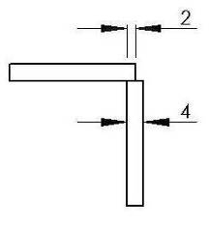 | 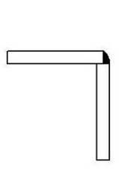 | 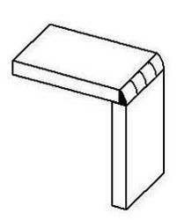 | 85-90A
4 X THICKER PLATE JOINT | 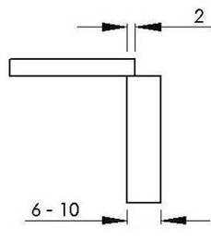 | 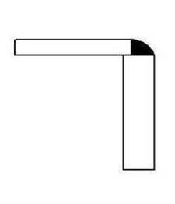 | 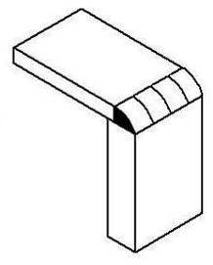 | 125-130A
TUBE TO TUBE PLATE | 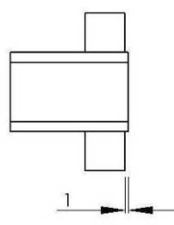 | 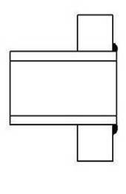 | 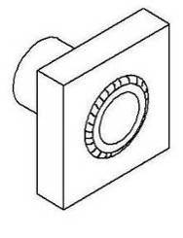 | 55-60A
STAYS |  |  |  | 55-60A
BUSHES |  |  | 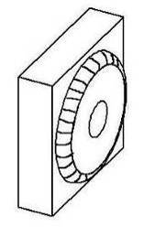 | 85-90A

